Results and Confusion Matrix
AI-Based Real-Time Anomaly Detection & Decision Support System for Deep Space Missions
NASA CMAPSS Turbofan Engine Degradation Dataset | India Space Academy
1. Confusion Matrix
The confusion matrices below compare how well each of the three anomaly detection models classified engine states as Normal or Degraded across the full test set. Each matrix shows four values: True Negatives (correctly identified normal engines), False Positives (normal engines wrongly flagged), False Negatives (degraded engines missed), and True Positives (correctly detected degraded engines).

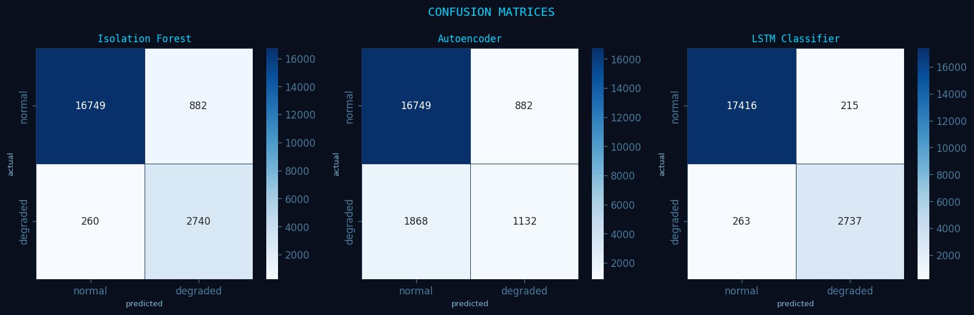
Figure 1: Confusion Matrices — Isolation Forest, Autoencoder, and LSTM Classifier
Isolation Forest detected 2740 degraded engines correctly but produced 882 false positives — engines it flagged as degraded when they were actually normal. This is a safe trade-off for health monitoring since the cost of missing a real fault is higher than a false alarm.

The Autoencoder performed significantly worse in recall, missing 1868 degraded engines entirely (false negatives). This makes it unreliable as a standalone anomaly detector in mission-critical scenarios where undetected engine failure is not acceptable.

The LSTM Classifier achieved the best balance — only 215 false positives and 263 false negatives, while correctly identifying 2737 degraded engines and 17416 normal ones. This makes it the most reliable model for autonomous deep space decision support.

2. RUL Prediction Results
Remaining Useful Life (RUL) prediction estimates how many operational cycles remain before an engine requires maintenance. The scatter plot shows predicted RUL against true RUL for all 100 test engines, with the dashed red line representing perfect prediction. Points close to this line indicate accurate predictions.

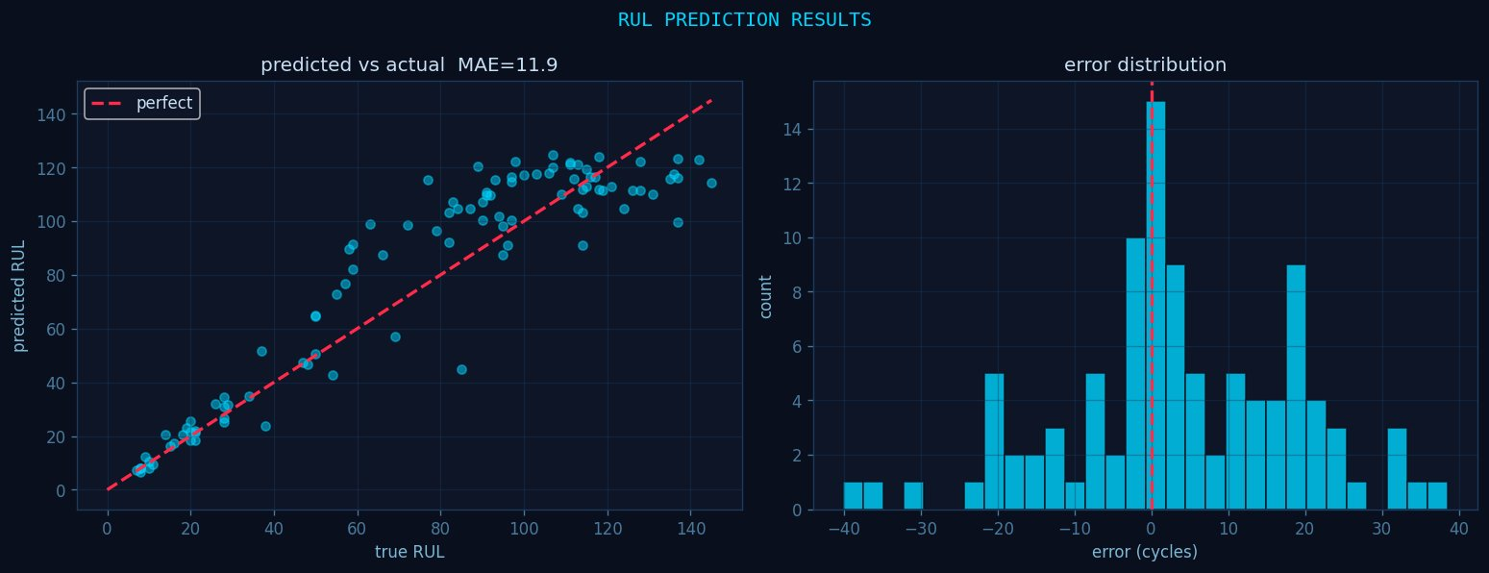
Figure 2: Predicted vs Actual RUL (left) and Prediction Error Distribution (right) — MAE = 11.91 cycles, RMSE = 15.63 cycles
The model achieves a Mean Absolute Error (MAE) of 11.91 cycles, meaning on average predictions are within roughly 12 cycles of the true remaining life. The RMSE of 15.63 cycles reflects sensitivity to a few larger outlier errors visible in the scatter plot. The error distribution histogram is centred around zero, confirming the model has no systematic bias — it neither consistently overestimates nor underestimates engine life.

3. Fleet Status — 100 Test Engines
The fleet dashboard visualises the predicted RUL for all 100 test engines simultaneously. Engines are colour-coded by operational urgency: green (RUL > 80 cycles, safe to continue), orange (30 < RUL ≤ 80 cycles, schedule maintenance), and red (RUL ≤ 30 cycles, critical intervention needed).

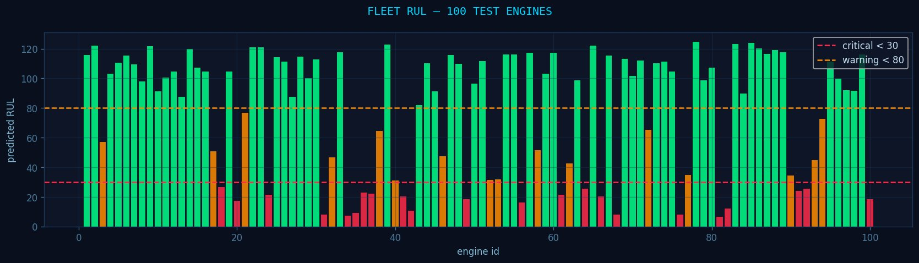
Figure 3: Fleet RUL Dashboard — 100 Test Engines colour-coded by health status
Out of 100 test engines, 62 are operating normally, 16 are in a warning state, and 22 are in a critical state requiring immediate attention. This fleet-level view directly demonstrates the decision support capability of the system — in a real deep space mission, this dashboard would allow an autonomous onboard system to prioritise maintenance and prevent catastrophic engine failure.

4. Real-Time Engine Monitor — Live Feed (Animated Dashboard)
Note: This dashboard is a live animated simulation — the actual output is a GIF where all panels update in real time cycle by cycle. The image below is a snapshot from the most critical moment in the animation (Cycle 162, EMERGENCY state).

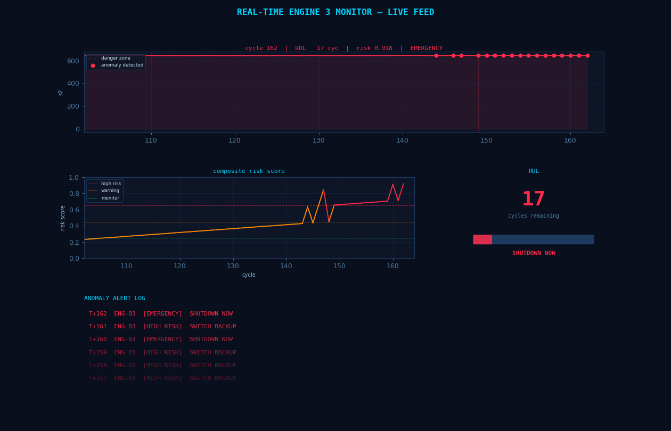
Figure 4: Real-Time Engine 3 Monitor — Snapshot at Cycle 162 | RUL = 17 cycles | Risk Score = 0.918 | Status: EMERGENCY
The animated dashboard tracks Engine 3 in real time across 180 operational cycles. It consists of four live-updating panels:

Top panel — Sensor trace: Plots raw sensor readings cycle by cycle. Red dots mark anomaly detection events. The orange shaded region above the danger zone line indicates the engine has entered a degraded operating range.
Bottom-left — Composite risk score: A running risk index built from model outputs. The green line (monitor threshold ~0.22), orange line (warning threshold ~0.43), and red dashed line (high risk threshold ~0.65) define alert zones. In the snapshot, the score has crossed the high-risk line, triggering the EMERGENCY status.
Bottom-right — RUL counter: Displays the predicted remaining useful life in cycles, updating every frame. The progress bar shrinks as cycles deplete. At Cycle 162 shown here, RUL has dropped to 17 cycles and the bar reads SHUTDOWN NOW — the autonomous decision support system has recommended immediate engine shutdown.
Anomaly Alert Log: A scrolling log records every alert event with timestamp (T+cycle), engine ID, severity level, and recommended action. In this frame, the log shows back-to-back EMERGENCY and HIGH RISK alerts from cycles T+157 to T+162, all recommending SWITCH BACKUP or SHUTDOWN NOW.

The animation begins with all systems nominal (green, RUL ~177), transitions through a MONITOR phase around cycle 80–100 as the risk score starts climbing, escalates to HIGH RISK and then EMERGENCY in the final 20 cycles, and ends with a full critical alert — demonstrating the complete lifecycle of engine degradation detection in a simulated deep space scenario.

India Space Academy | 21-Day AI/ML Project | Raja | Hindu College, University of Delhi

